

LONG-PERIOD MAGNETOTELLURIC STATION (MTS) LEMI-424

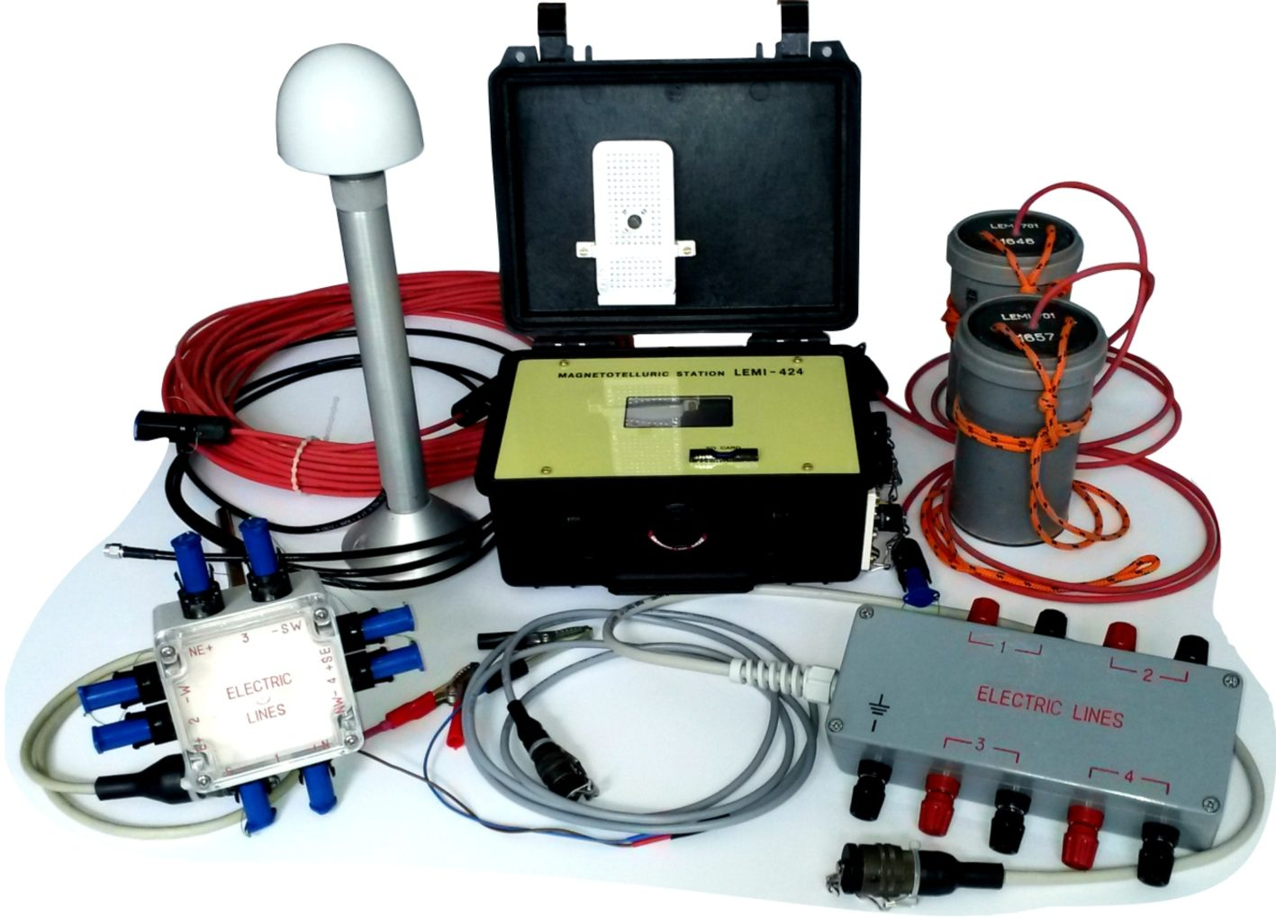
Main features:

High resolution and accuracy
- Very low noise
- 4 electric and 4 magnetic channels
- Very low temporal and thermal drift
- Low power consumption
- 8 GB SD card
- Satellite synchronization
- Graphic display with touch screen
- USB output
- Waterproof plastic case
- Two models of lightning protection units to choose

The Long-Period Magnetotelluric Station LEMI-424 is composed of two units - Data Logger (DL) and Analog Magnetometer (AM). DL (at the photo above) is developed for the analog signals received both from AM and from electric lines for telluric field measurements digitizing and storage. In order to realize the design of electric channels major attention was paid to thermal and temporal stability, high input impedance and low drift. High-pass filter-free technology of input stages was used in order to let super-long period signals (up to 100.000 second) to pass. The lightning protection unit (at the photo, two models shown left and right, below) allows both the protection against nearby lightning discharges and easy connection of electric lines in the field. Specially developed very low noise LEMI-701 electrodes are recommended (at the photo, upper right), but any other electrode types may be used too.

MAIN TECHNICAL PARAMETERS

Frequency band | DC-0.5 Hz
Measured range | ±2450 mV
Resolution of electric meter along each component (ADC 32 bit) | 2 nV
Sample rate | 1 per s
SD card | 8 GB
Digital output and control | USB
GPS timing, coordinates and altitude determination (antenna cable length 3m)
Operating temperature range | minus 20 to +60°C
Power supply | (5-20) V
Power consumption | <0.35 W
Weight:  Electronic unit  Lighting protection unit | 2.0 kg  1.1 kg
_______________________________________________________________________________
LLC “LEMI”, 5A Naukova St., Office 301, Lviv, 79060, Ukraine
Tel/Fax: (380) 32 2540251; E-mail: lemi@isr.lviv.ua; www.LEMIsensors.com

3-component analog Magnetometer

Main features:  - High resolution and precision  - Low noise  - Low temperature offset  - Temperature channel  - Convenience of installation and service  - Low power consumption  - 3 years operational guarantee | 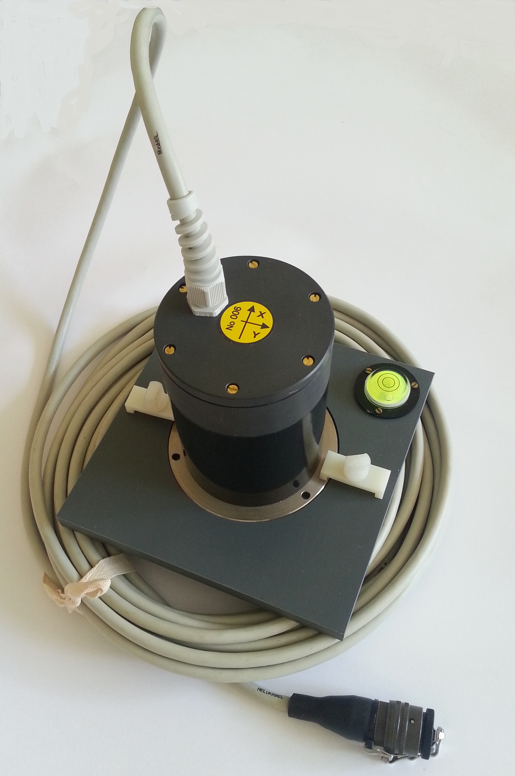

LEMI-424 Long-Period MT Station includes as the second unit the vector AM for the precise measurement of Earth's magnetic field and its variations at land conditions as well as in geomagnetic observatory (at the photo, above). It is produced on the base of flux-gate sensor, all three components of which are implemented in the same body. The electronics is implemented as “black box” PCB with analog output fixed in the same housing which has to be connected to DL. It is also possible to use any other analog registration unit. Very low power consumption of the magnetometer allows using a small buffer battery what is convenient for long-term autonomous measurements in field conditions, where power breaks may often occur.

MAIN TECHNICAL PARAMETERS

Measured range at analog output | ±65000 nT
Frequency band for magnetometer | DC-10 Hz
Transformation factor of analog output | 25 µV/nT
Noise level at 1 Hz | ≤ 10 pT/√Hz
Temperature drift | < 0.3 nT/°C
Components orthogonality error | < 30 min of arc
Operating temperature range | minus 20 to + 60° C
Power supply | 5 V
Weight: sensor with support and 10m cable | 3 kg
Length of sensor connecting cable as manufactured | 6 m*
* any other values up to 75 meters are possible to use.
________________________________________________________________________________
LLC “LEMI”, 5A Naukova St., Office 301, Lviv, 79060, Ukraine
Tel/Fax: (380) 32 2540251; E-mail: lemi@isr.lviv.ua; www.LEMIsensors.com

