LABORATORY FOR ELECTROMAGNETIC INNOVATIONS


LEMI-423

WIDE BAND MAGNETOTELLURIC STATION
FOR FIELD SURVEY LEMI-423

Main features:
- 3 AC magnetic field sensors
- 2 telluric field channels
- Wide frequency range (0.0001…1000) Hz
- Satellite synchronization
- Excellent temperature stability
- Low noise level
- All sensors are calibrated
- Special software for real-time data acquisition and visualization
- Digital USB interface
- Two types of lightning protection units to select
Main applications:
- Exploration of gas, oil and other deposits
- Surveying deep Earth conductivity
- Basic regional survey
- Earthquakes monitoring

Composition (left to right):
- 3 induction sensors
- Electronic unit
- Lightning protection units
- GPS antenna
- Non-polarizing electrodes (optional)

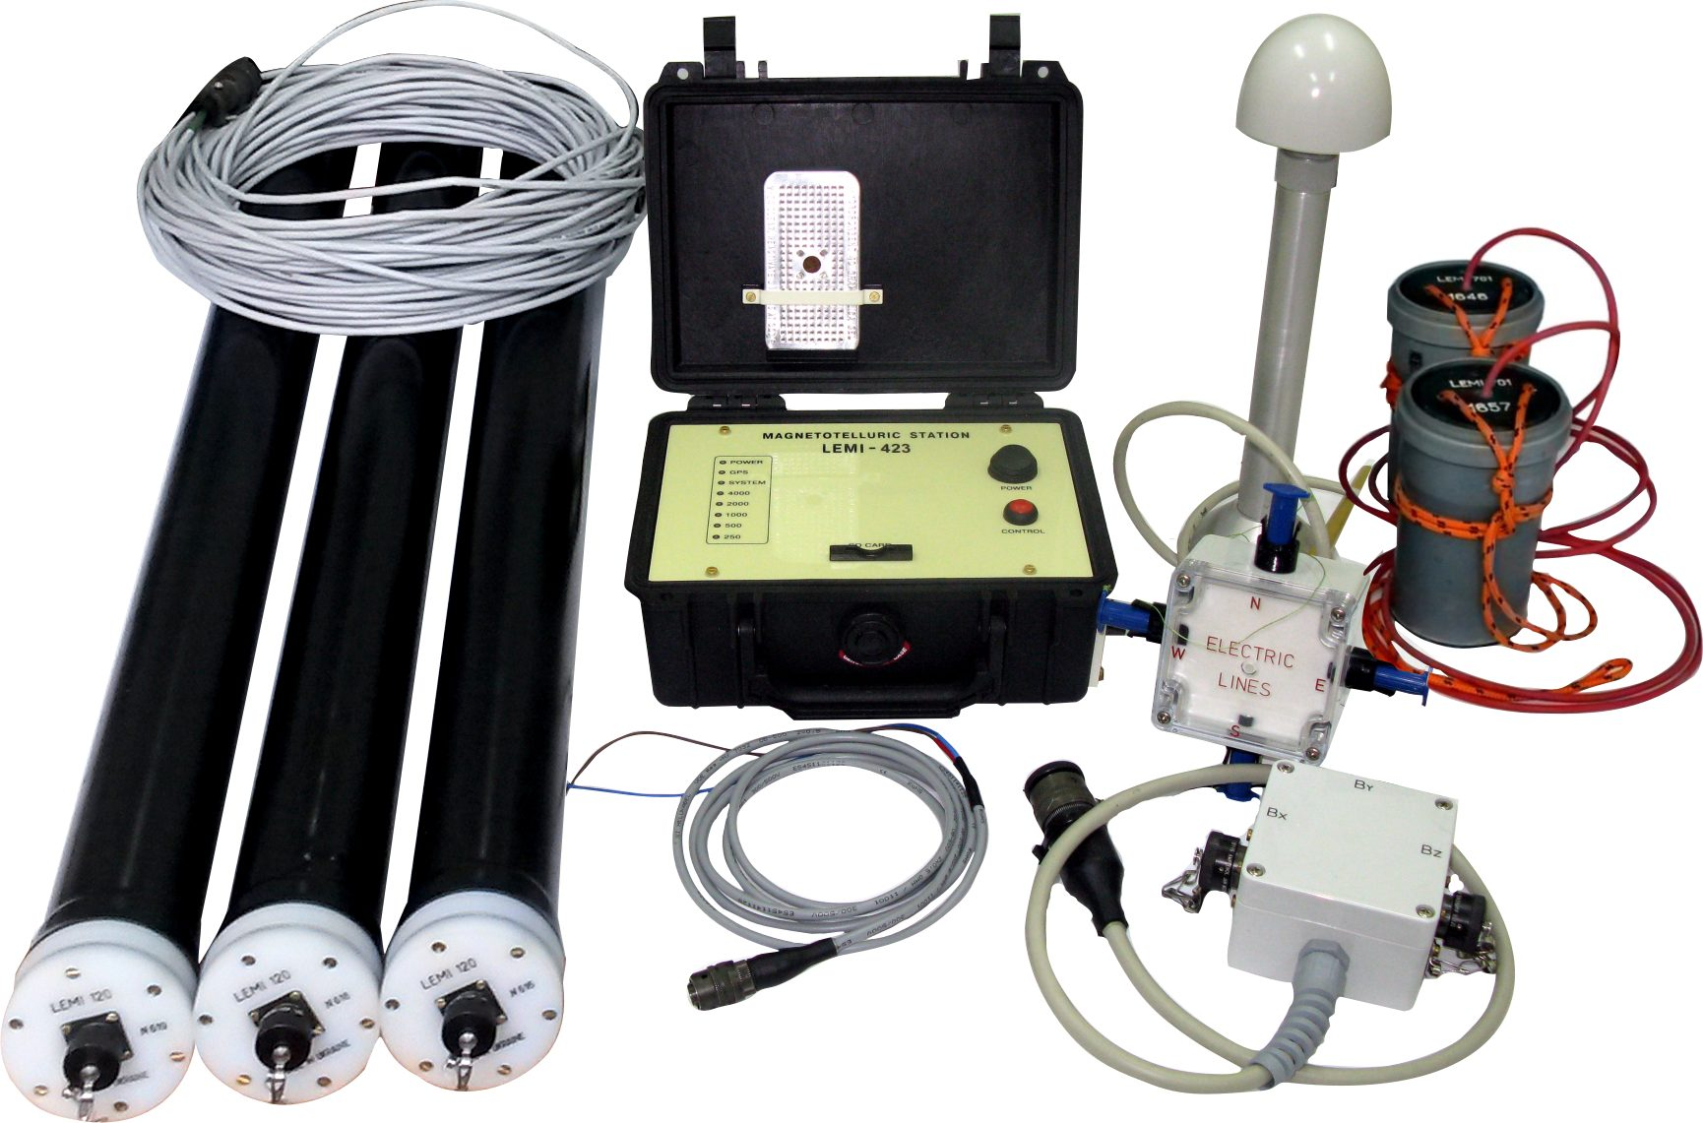

Wide band magnetotelluric station LEMI-423 is intended for the study of natural electromagnetic fluctuations in field conditions in wide temperature range. The station registers and digitizes automatically the data from 3 search-coil magnetometers and 2 electric channels and monitors the temperature of electronic unit. The electric channels include lightning protection unit, one of two its constructions differing by the way to connect electric lines (see photo) may be selected. The real time acquisition, recording and visualization of current and previously recorded data are executed in the external PC or in the Data Registration Unit (optional), to which digital data are transferred through USB port. The station operation is GPS synchronized.

1. Search-coil magnetometer
Frequency band | (0.0001-1000) Hz
Shape of transfer function | Linear-flat
Corner frequency | 1 Hz
Transfer factor at flat part (differential) | 200 mV/nT
Noise level:  at 0.001 Hz  at 0.01 Hz  at 1 Hz  at 300 Hz | < 100 pT/√Hz  < 10 pT/√Hz  < 0.1 pT/√Hz  < 0.01 pT/√Hz
Weight of one sensor | 5,8 kg
Output connectors type | MS3112E12-8S
2. Electric field meter
Frequency band (sample rate 4k) | (DC-1652) Hz
Measuring ranges (for measuring base 1 m):  at gain=4 | ± 500 mV
Noise level at 1 Hz | 35 nV/√Hz
Non-polarized electrodes (optional) own noise at 1 Hz | < 10nV/√Hz
3. Electronic unit
Number of channels:  Magnetic  Telluric | 3  2
ADC, bit | 32
SD card volume | 32GB
Sample rate per second | 250, 500, 1k, 2k, 4k
Power supply voltage | (9-18) V
Power consumption (with three induction coils) | 1.7 W
Weight | 2 kg
Operation temperature range | minus 20° to +60°C
Waterproof housing
Input connectors type (for induction coils connection) | MS3112E12-8S

LLC «Laboratory for Electromagnetic Innovations» («LEMI»),
5A Naukova St., Suite 301, Lviv, 79060, Ukraine
Tel/Fax: (380) 32 2540251; E-mail: lemi@isr.lviv.ua;
www.LEMIsensors.com

