Induction Magnetometer

for Geophysical Applications LEMI-142

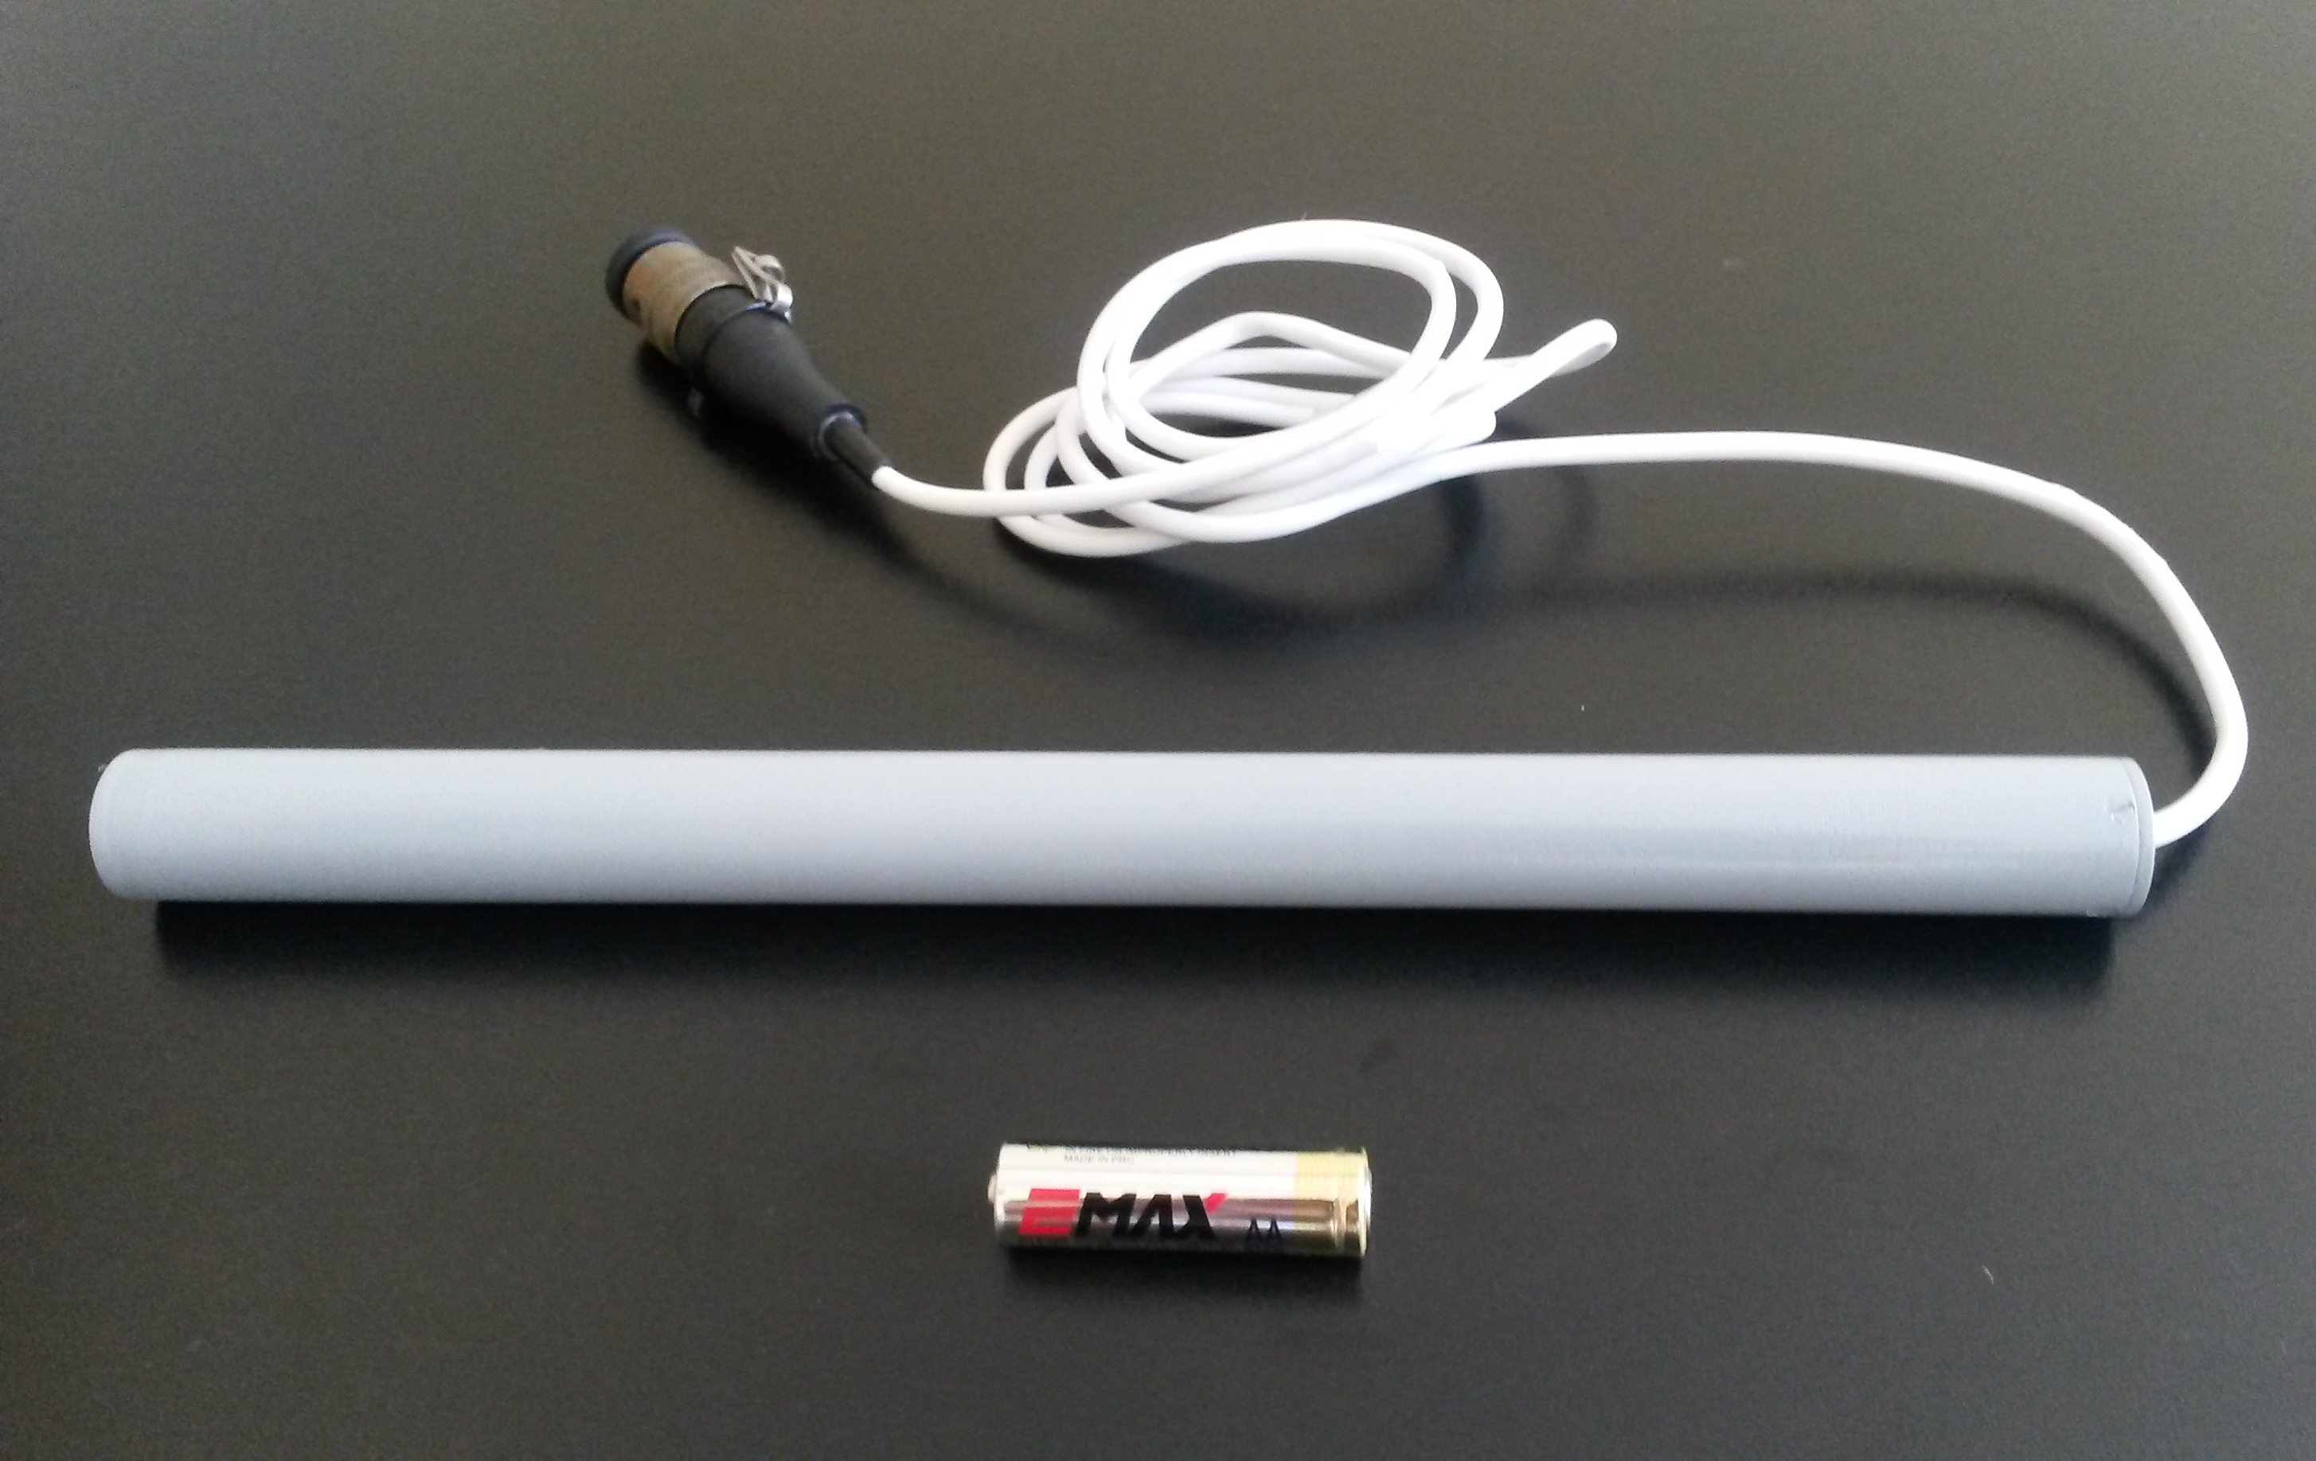
Main features:
- High sensitivity
  - Low noise, near the theoretically lowest possible level
  - Frequency band 1 ... 500 kHz
  - Low power consumption

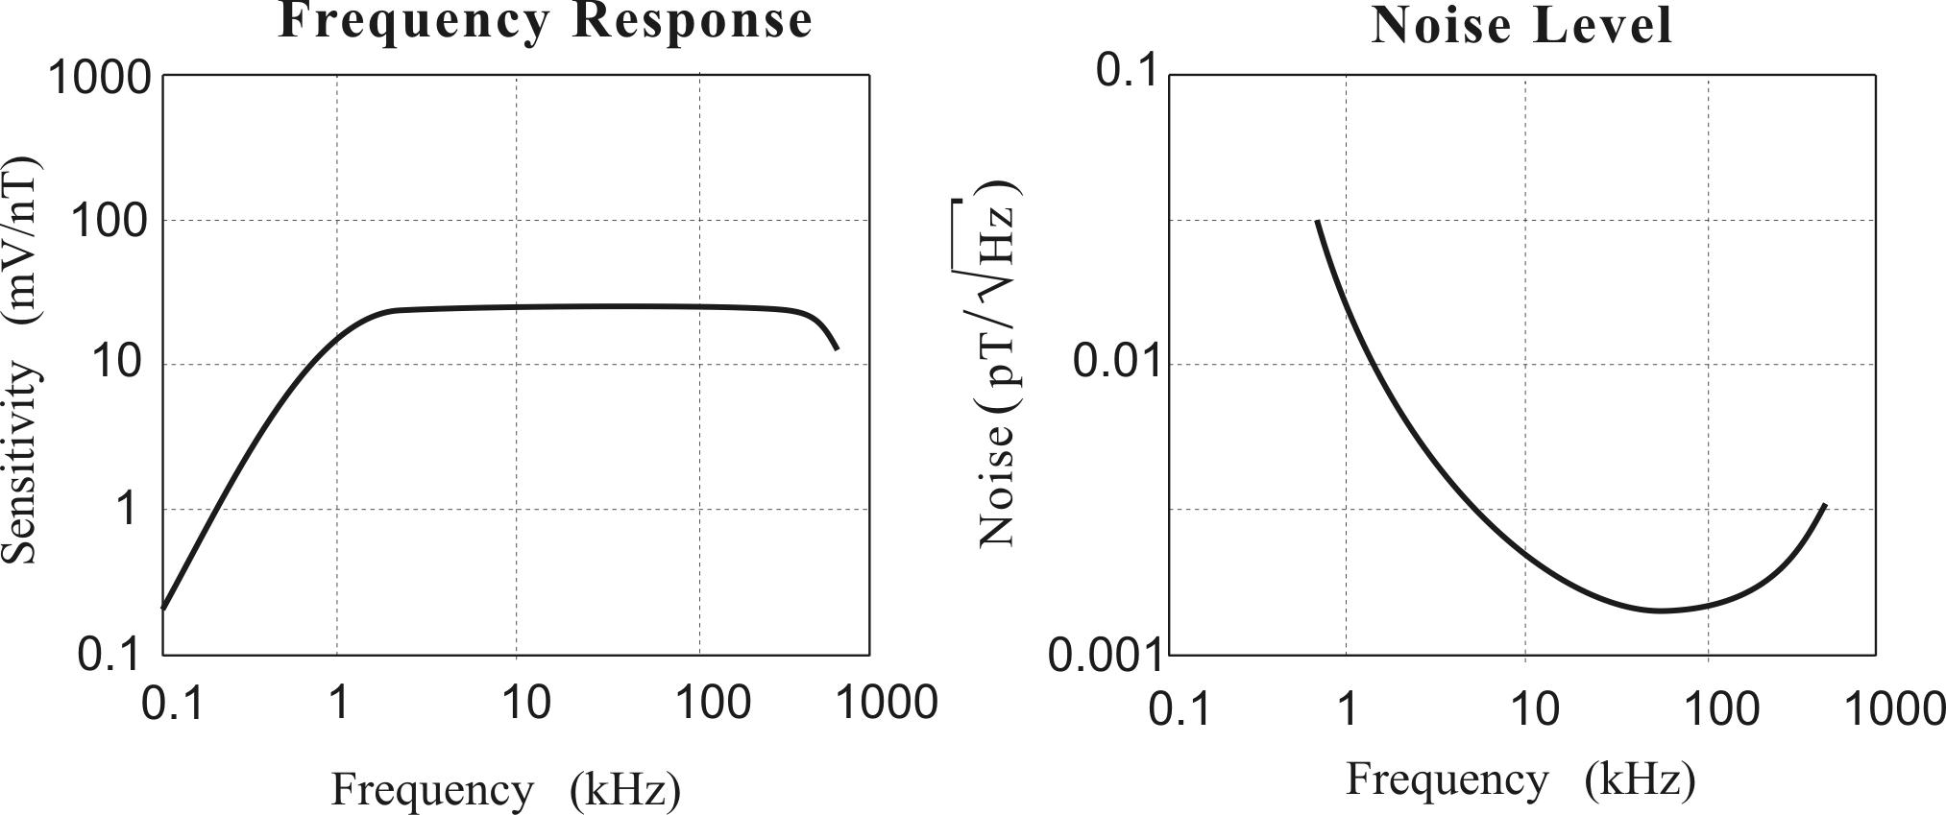
New calculation methodology using minimal mass criterion allowed minimizing the weight, conserving low noise level in wide frequency band. The magnetic feedback design is utilised what provides a stable response of full frequency band. Low noise preamplifier is placed inside the sensor body.

TECHNICAL SPECIFICATIONS

Frequency range | 1 ... 500 kHz
Sensitivity | 25 mV/nT
Magnetic noise level | 1,5*10⁻¹⁵ T/ √Hz
Length | 310 mm
Weight | 250 g
Power consumption at ±12 V | 7 mA

